Specifications
  - TRIS-LDo-1125 - Sizes on sales units of measure
Doc Version 3.0

Customer: | TRISA AG
Project: | Support Project
proALPHA version: | 7.1e00-CH04
proALPHA Installation(s): | CH
GUI language: | German
Author: | Loïc Dobler
Created on: | 05.07.2023
Last change on:
Contact Customer: | Peter Kälin

This document describes a modification or expansion of the standard software proALPHA and has been checked by the customer. The functional design in chapters 2 - 4 is hereby released for technical specification and costing in compliance with the requirements in section "Final Provisions":

......................................................
Date and Signature of Customer

Contents
1. [UPDATE THE TABLE] 3
1.1 [UPDATE THE TABLE] 3
1.2 [UPDATE THE TABLE] 3
1.3 [UPDATE THE TABLE] 3
2. [UPDATE THE TABLE] 4
2.1 [UPDATE THE TABLE] 4
2.2 [UPDATE THE TABLE] 4
2.2.1 [UPDATE THE TABLE] 4
2.2.2 [UPDATE THE TABLE] 5
2.3 [UPDATE THE TABLE] 6
3. [UPDATE THE TABLE] 7
3.1 [UPDATE THE TABLE] 7
3.2 [UPDATE THE TABLE] 7
4. [UPDATE THE TABLE] 8
4.1 [UPDATE THE TABLE] 8
4.2 [UPDATE THE TABLE] 8
4.3 [UPDATE THE TABLE] 8
5. [UPDATE THE TABLE] 9
5.1 [UPDATE THE TABLE] 9
5.1.1 [UPDATE THE TABLE] 9
5.1.2 [UPDATE THE TABLE] 9
5.1.3 [UPDATE THE TABLE] 9
6. [UPDATE THE TABLE] 10
7. [UPDATE THE TABLE] 11
7.1 [UPDATE THE TABLE] 11
7.2 [UPDATE THE TABLE] 11
8. [UPDATE THE TABLE] 12

Requirements

References

Request by e-mail from Peter Kälin to Andreas Weber on Thursday, June 29, 2023 1:04 p.m.

Summary and Objectives

TRISA AG wants to be able to enter the sizes depending on the part sales unit of measure records.

The sizes Length, Width and Height are to be displayed as new fields in the part sales unit of measure relationship window for the entry.
In addition, below these 3 new fields, the Net Weight field is to be recalculated.

Description of requirements

Four new fields are to be added to improve the use of sales unit of measure sizes.
Available:

- Length
- Width
- Height
- Net weight

In the "Parts Sales Units of Measure" program of the data migration tool, this should also be possible to import the three new fields Length, Width and Height into the part sales units of measure records.
เพิ่ม Field ใหม่ 3 ฟิลด์ และต้องมีฟิลด์ Net weight ที่จะคำนวณ Length, Width and Height อัตโนมัติ

Functional design

Summary of the Solution
For a better use of the sales unit of measure sizes, the length, width and height are to be entered depending on the part sales unit of measure records.
In addition, a new "Net Weight" field is to be calculated.
ให้ Net weight มาคำนวณค่า ความยาว ความกว้าง และความสูง โดยขึ้นอยู่กับหน่วยวัด

In addition, the Migration Tool Sales Unit of Measure is to be expanded with the 3 fields Length, Width and Height so that these sales units of measure for each part can also be entered via the migration.

เพิ่ม ฟิลด์ Length, Width and Height โดยสามารถป้อนค่าเข้าไปได้ สำหรับสินค้านั้นๆ

Description of the solution

Provide New Fields

The part sales units of measure mask is supplemented with 4 new fields:

- Length
- Width
- Height
- Net weight

Each of these 4 new fields will have the following decimal format: zzz,zz9.9999
ทั้ง 4 ฟิลด์ กำหนด format: zzz,zz9.9999

The 3 fields Length, Width and Height are freely opened for the entry.
ฟิลด์ Length, Width and Height สามารถกรอกข้อมูลได้ตามต้องการ

The unit "mm" is to be displayed behind the Length, Width and Height fields, because the company
Trisa AG will always update these fields in mm.
หน่วย mm จะแสดงอยู่หลัง Length, Width and Height fields

The Net Weight field is calculated as follows and should be blocked from being entered:
ฟิลด์ Net Weight ต้อง Read-Only เท่านั้น

Net weight =
StUM-SaUM factor (from sales unit of measure) X Wgt/StUM (from Basis of Part tab)
ฟิลด์ Nettogewicht = Faktor LME-VME * Gew/LME

In addition to this field, the unit of measure is also to be displayed as a text. It is simply taken from the part master files: abbreviation unit of measure from the "Weight UoM" field

In addition, all these 4 new fields are to be displayed as a column in the browser of the sales units of measure.
ให้เพิ่ม 4 ฟิลด์ ใน Browse Column

The Weight field in the Sales Unit of Measure mask is to be renamed "Gross Weight".
In addition, the unit of measure "kg" is to be displayed (fixed):

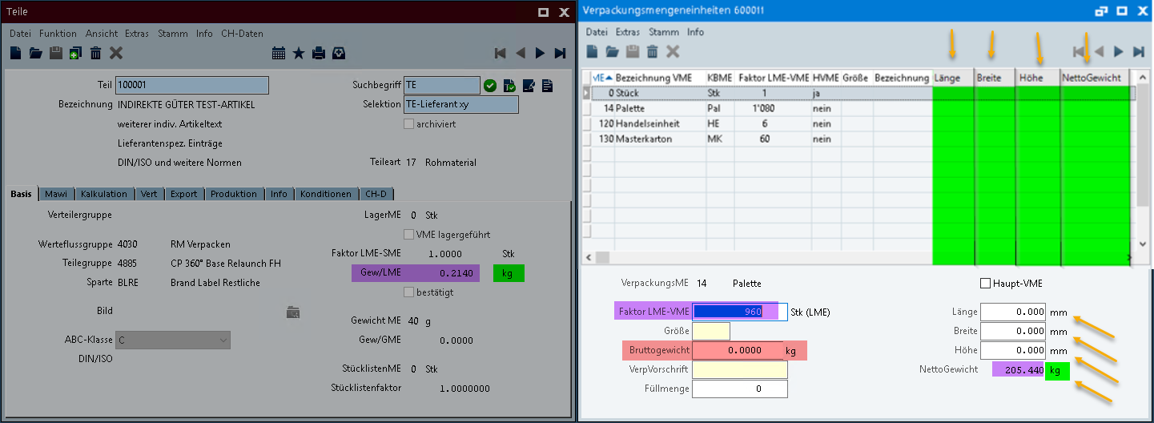

Business Logic & GUI

Data Model

Differentiation
The customization refers to the tables, fields and programs mentioned.
These specifications do not automatically add functional extensions to the modules of the proALPHA environment, such as the DMS, Analyzer, reports, and forms. The proALPHA Help is not automatically extended either.
Changes to adjacent modules/programs must be described and defined in the specifications sheet.

Test cases
The specified test cases map the customization described here and are the basis for the acceptance of the software.

Enter and save fields
Pt | Explanation | Expected result | Test data
 | The 3 new fields are to be entered in the part sales units of measure mask | The 3 new fields Length, Width and Height can be entered and saved.  The Net Weight field is to be calculated correctly and blocked from being entered.  The abbreviation Unit of Measure next to the Net Weight field should correspond to the abbreviation Unit of Measure "Weight UoM" from the part master files.
 | Test result (incl. screenshots)

Data import part sales units of measure
Pt | Explanation | Expected result | Test data
 | Start the data migration tool, "Parts Sales Units of Measure" program.  Create test file according to import layout and start import program. | The 3 new fields Length, Width and Height are to be loaded / updated with the examples of the test file.
 | Test result (incl. screenshots)

Requirements

Technical Requirements
The use of proALPHA functionalities outside the concurrent user model (connection of external systems, background processing) requires the licensing of so-called software services.
"Use of proALPHA functionalities" refers to any use or access to the proALPHA infrastructure, e.g.
- Writing to proALPHA data structures
- Calling proALPHA classes and other business logic
- Opening proALPHA Services

Organizational Requirements

Notes about the go-live

Technical Design

<Template for Section>

GUI

Business Logic

Data Model

Final Provisions
These specifications form the basis for customer-specific extensions of the standard software proALPHA®.
The customer-specific extensions only cover the area defined in this specification sheet. Functionality beyond this scope is not provided.
Unless explicitly agreed otherwise, the customer-specific extensions are only created in German: no programs, program parts or data are translated into other languages. This also applies to the languages supported by ^{proALPHA®} in the standard version.
The customer-specific extensions are thoroughly tested before they are delivered. However, for technical reasons, it is not possible to perform the test under the same conditions and with the same data as the customer will use. It is therefore recommended to carefully check the functions in the real system environment after their delivery.
The Customer is aware that the transfer of the functions defined in this specification sheet to new versions of proALPHA® may require deviations in the display details or handling. This specification sheet also remains valid in this case, provided that there is a maintenance agreement for the customer-specific extensions defined in this specification sheet and no changes to the functionality have to be agreed on.
This specification sheet documents the customer-specific extensions. No other documentation beyond the specifications contained in this specification sheet is to be provided. Questions about customer-specific extensions are received and forwarded by the hotline.
By signing on page 1, you confirm:
that the specification sheet is accepted in this version and becomes part of the contract,
that this specification sheet defines the functional scope of the software to be created and that there are no side agreements regarding the functionality.

Annex

Table of Figures
No entries could be found for a table of figures.

Table of tables
TOC \h \z \c "Tabelle" No entries could be found for a table of figures.

Change History
Doc. -  Version | Date | Specialist | Initiator | Chapter | Explanation
3.0 | 05.07.2023 | Loïc Dobler | Peter Kälin | All | Initial new entry
3.0 | 29.08.2023 | Loïc Dobler | Peter Kälin | All | Change of request for quote by Peter Kälin

